Individual Activity 4: Design Your Own System Using UML
System: SecureExam (Online Examination System)

Subject: Application Development and Emerging Technologies
Name: Ruby Janne Batiancila BSIT 3B Date: May 4, 2026

Part 1: System Idea & Recall

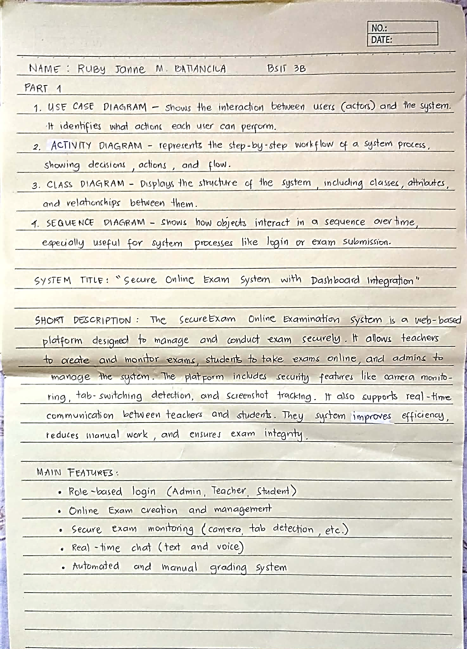

Part 2: UML Diagram Creation
- Use Case Diagram

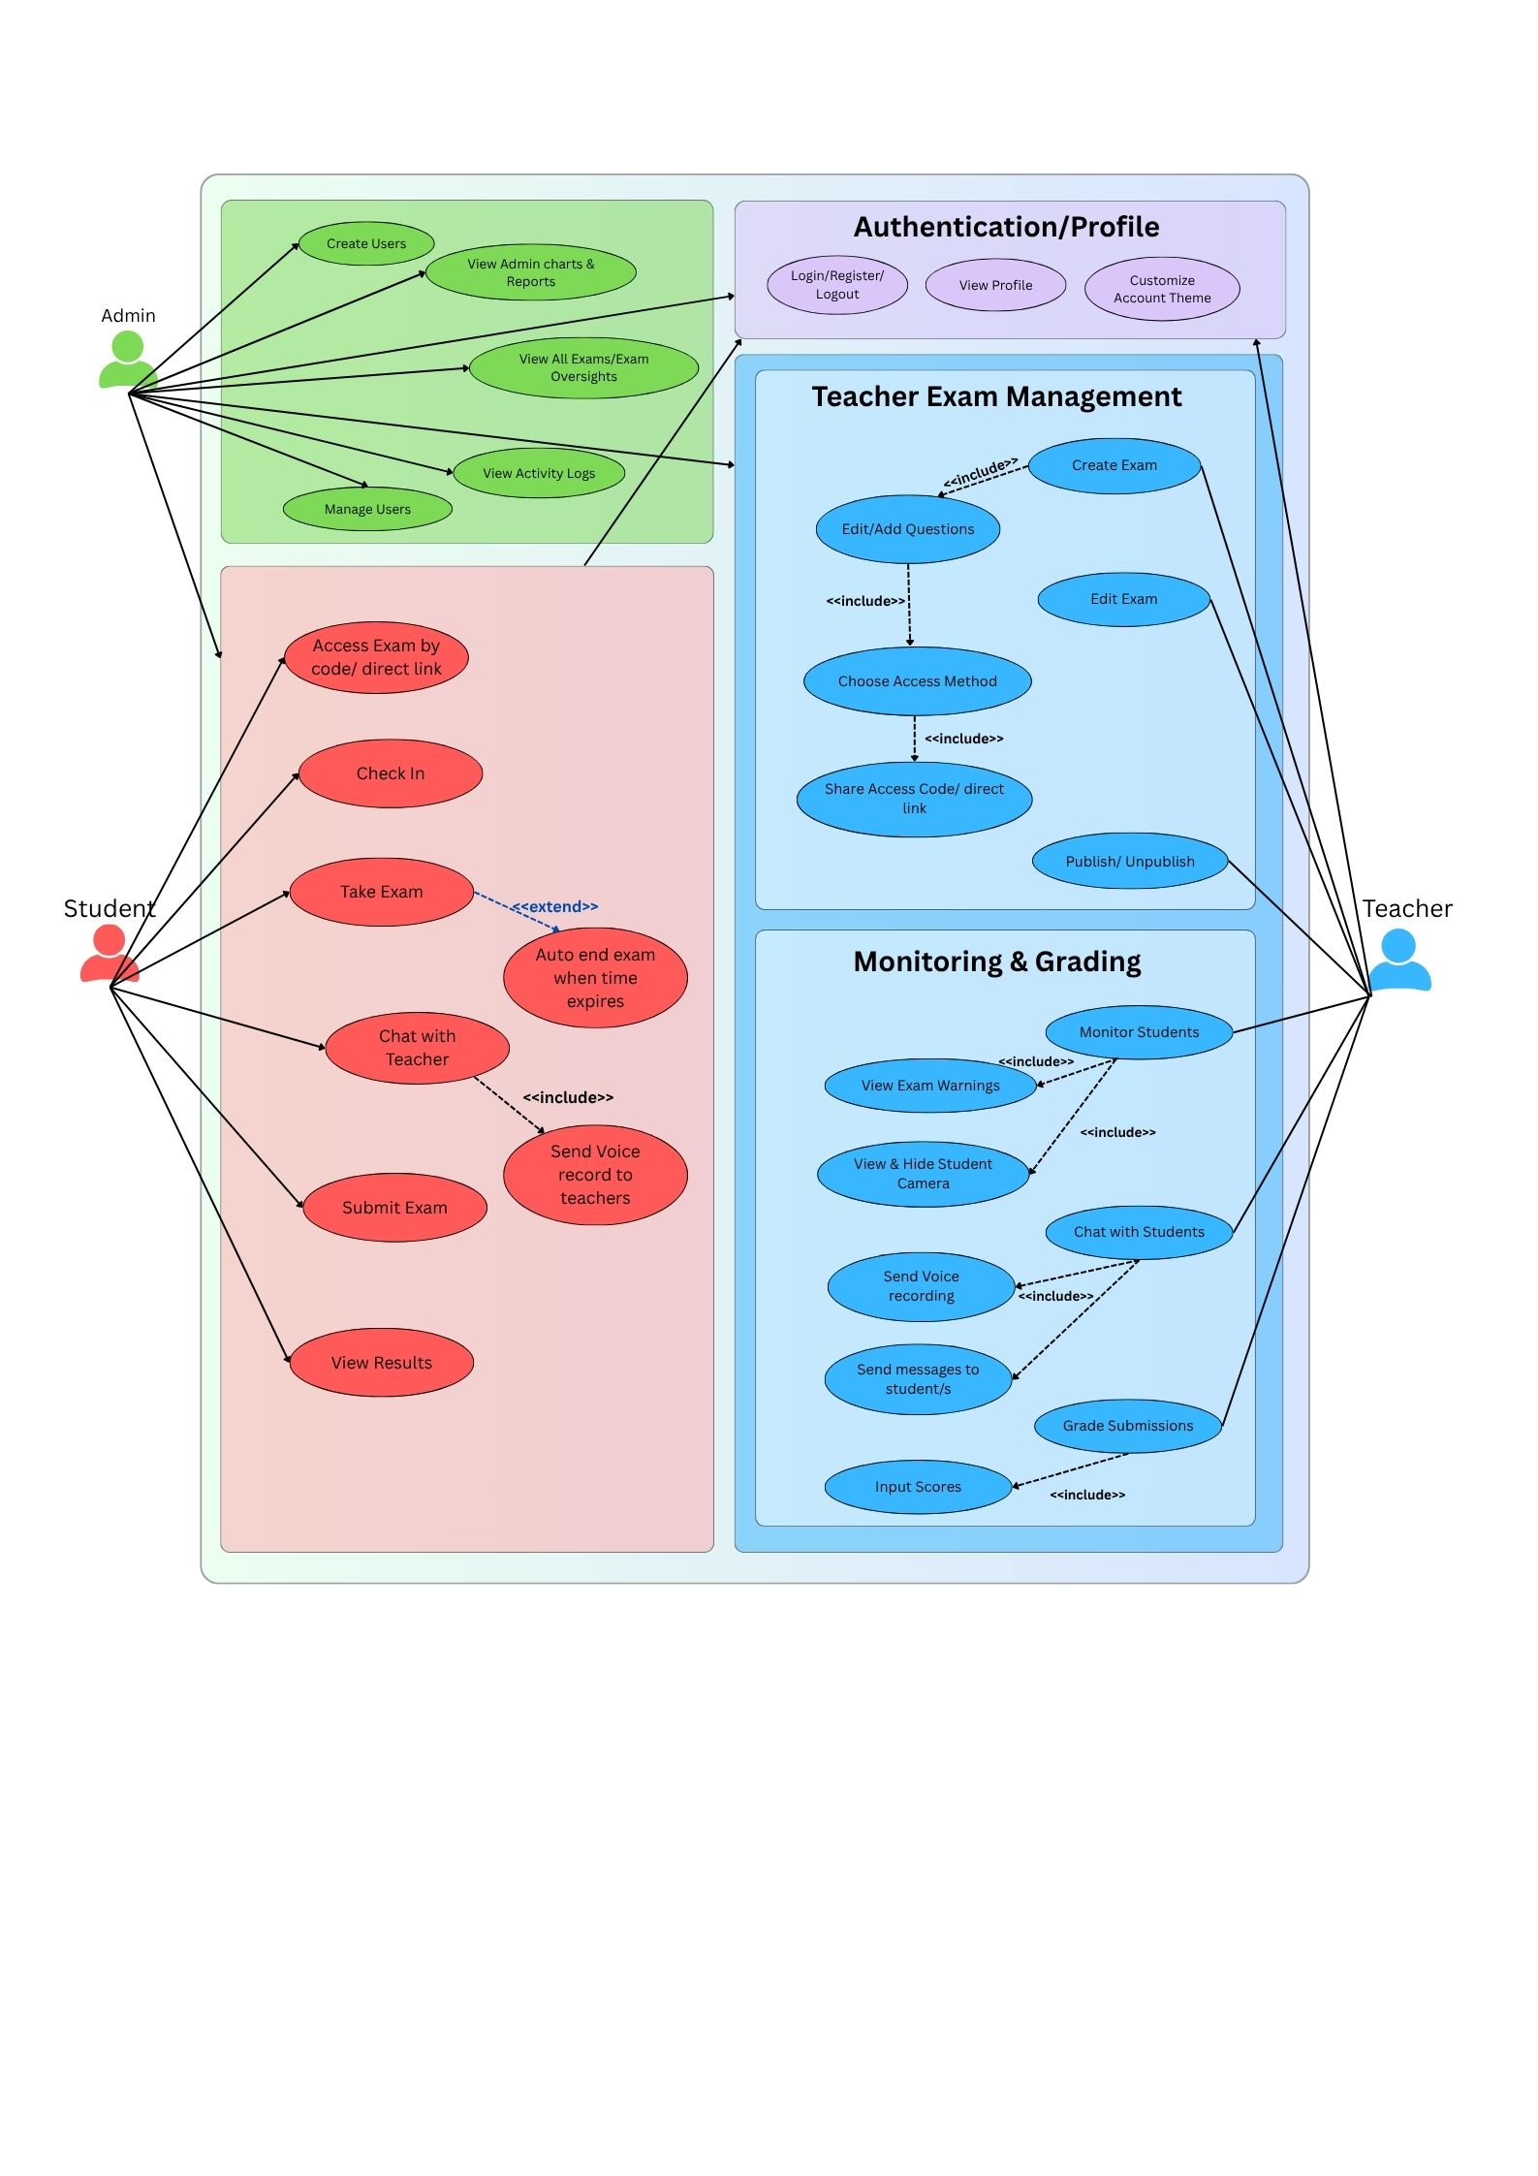

- Activity Diagram

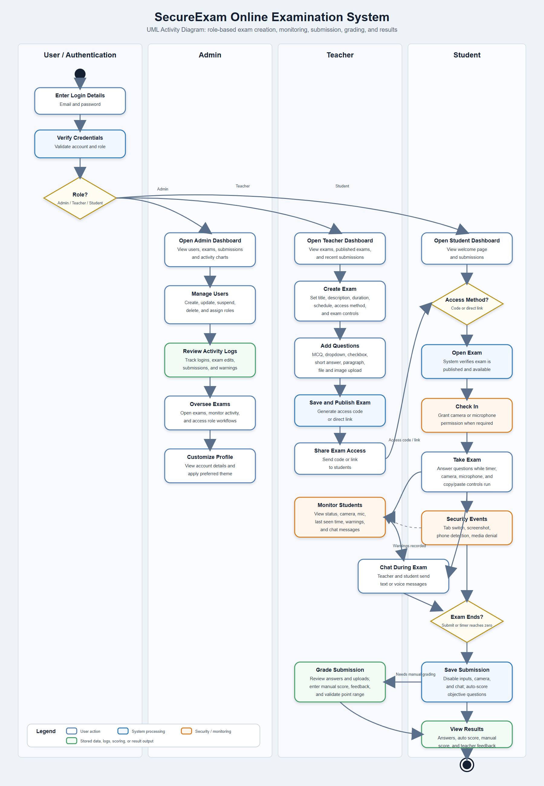

Part 3: SDLC Application
- Planning: In the planning phase, the main problem is identified: teachers need a faster and safer way to create, conduct, and check exams online. The team also decides the users of the system, such as admins, teachers, and students, and lists the features each role needs.
- Design: In the design phase, the dashboard layouts, database tables, and UML diagrams are prepared. This makes the system clearer before coding because the team can already see how exams, questions, submissions, warnings, and chat messages should work together.
- Implementation: In the implementation phase, the SecureExam system is built using Laravel for the backend, HTML/CSS/JavaScript for the interface, and MySQL for storing the data. The features are added step by step, such as login, exam creation, monitoring, submission, grading, and reports.
- Testing: In the testing phase, each feature is checked to make sure it works correctly. For example, the team tests if students can only access published exams, if the timer disables the exam when time ends, and if warning events are recorded properly.

PART 4: REFLECTION
1. What did you learn from creating UML diagrams?
I learned how UML diagrams help visualize how a system works before development. They make it easier to understand user interactions and system processes clearly.

2. Why is planning (SDLC) important before building a system?
Planning is important because it ensures the system is well-organized, reduces errors, and helps developers understand what to build before coding.

